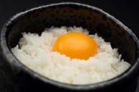い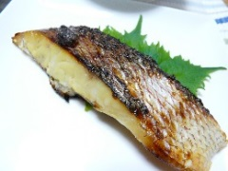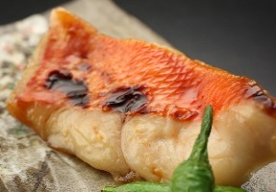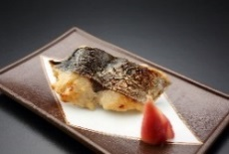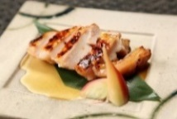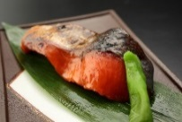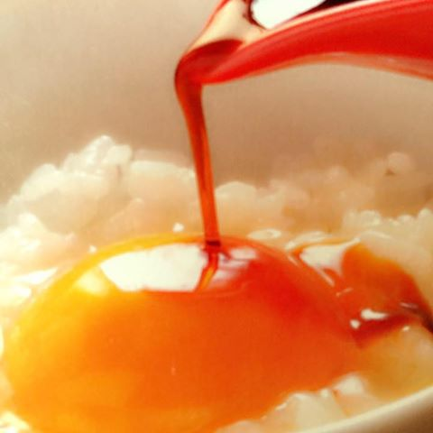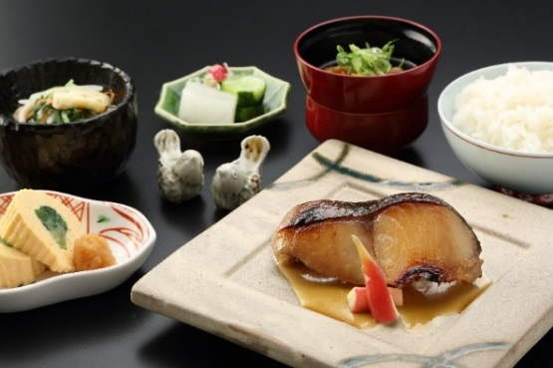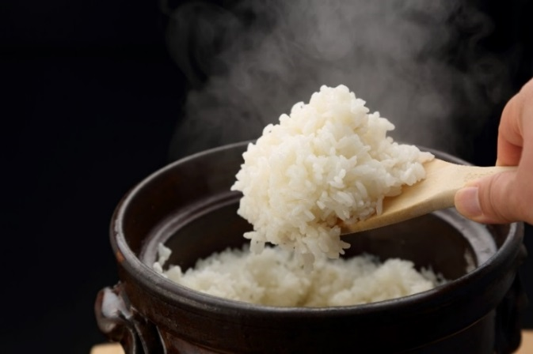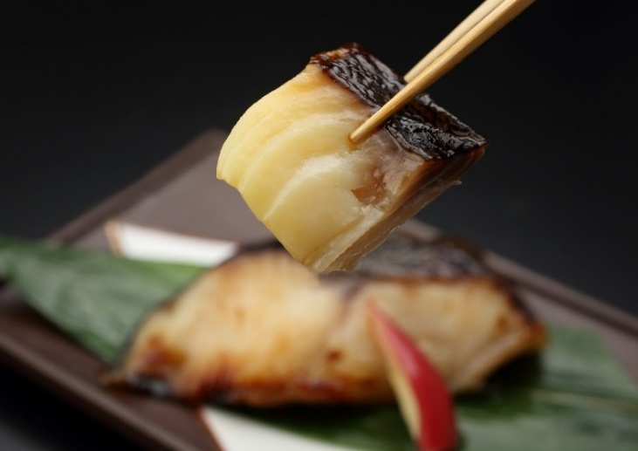

ごはんおかわり　　￥２００

Another bowl of rice

京都美山のたまご￥２００

A raw egg produced in Miyama, Kyoto

**Let's 　Try !**

If you don’t mind eating raw egg as a topping on rice,

we suggest　that you try one this time with your set menu!

This egg was produced in Miyama, Kyoto where is abundant

With natural surroundings.

It comes with a special soy sauce which goes very well with

This raw egg putting on the rice. Raw egg makes the rice

Milder and surprisingly goes well with any main dish.

JapaneseSpanishMackerel

\1,800

**西京漬セット（西京漬1種類・小鉢2品・ご飯・香の物・赤出汁）**

**Set Menu: Saikyo-zuke(main dish), 2 side dishes, rice, pickles, miso soup**

**※お好きな西京漬を1種類お選びください。**

**※Please choose your main dish from the list.**

Sea bream

\2,000

Pork

\2,000

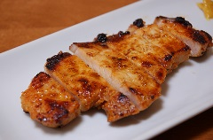

Alfonsino

\2,000

Chicken

￥1,800

Rose fish

￥1,800

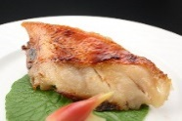

Salmon

\1,8000

（画像はすべてイメージです。）

Saikyo-zuke is grilled fish or meat pickled in Kyoto-style miso.

It has been widely enjoyed by Kyoto people.

京都の伝統料理《西京漬》

新鮮な食材を西京味噌にしっかりと漬け込み,じっくりと

焼き上げることで更なる美味しさを引き出した逸品です。

西京漬と釜炊きごはん